Task 5.4 – Sprint Retrospective

Isaac Pittolo – 7695438  
Hoang Linh Bui – 100017631  
Adam Bubonya - 9986677

# Team’s Velocity

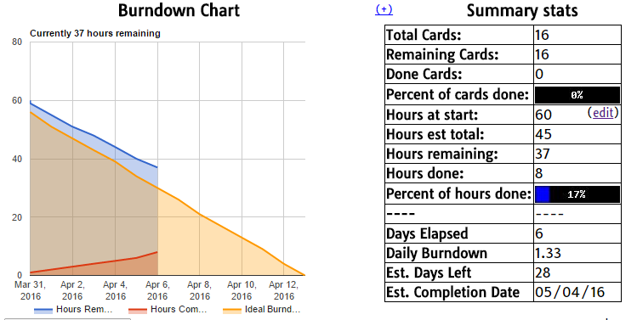

Figure 1. Burndown Chart

## Did we overestimate our ability?

Judging from our burndown chart, it looked like we started at a decent rate. However, we heavily fell out of track and severely overestimated our ability to work as a cohesive team.

Our greatest issue was just a lack of communication. In the case of Adam and Isaac, there were large parts of this project that we did not understand at all, nor the process or thought behind it. A large part of that came from our lack of ‘real world’ programming experience as well as our understanding of C#.

However, a lot of that is just excuses. In the end, I think we were just a bit lazy when it came to doing these tasks. It is a bit loathsome to admit but in reality, we could have avoided the issues we faced if we had just spoken up a bit during our physical meet-ups during the tutorials.

Credit to Hoang however, he has attempted to pull us together for the upcoming sprint and we feel our progress will improve immeasurably in comparison to this week’s performance.

## How can we get a better understanding of the Complexity of this task?

To better understand this subject, Hoang has uploaded previous semester slides from DP1. Adam and Isaac are to also learn how to use the Github command line utility to better branch, pull and merge commits.

Finally, we need to learn how to communicate. The next sprint we will demonstrate how we did this.

## Team Process

Next sprint I think we will be able to demonstrate real progress. After our blunt discussion in the tutorial, we all have a better understanding with what we need to do. Our discussions with our tutor helped immeasurably as well, we received solid advice on how to proceed and steps we will need to take.

What worked:

* Hoang performed admirably
* The ‘back end’ systems were all available – Trello, Burndown for Trello, and our Github page.
* The first half of Sprint 1 went well.

What did not work:

* We fell off heavily after a while, unable to communicate nor proceed in work
* We underestimated the complexity of the tasks
* Adam and Isaac struggled to contribute anything.

Ultimately, this will all need to be demonstrated in the next Sprint, and hopefully we can show our improvement in the future.